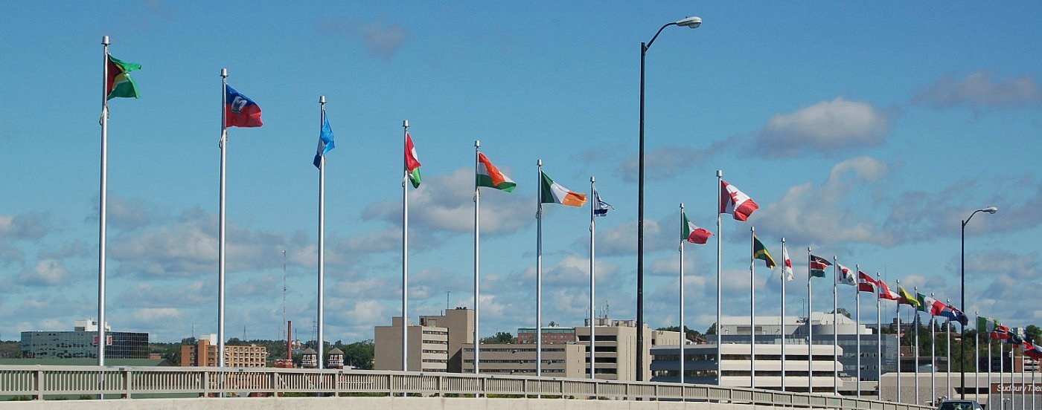

SUDBURY CHAPTER

For Sudbury membership, one must be a member in good standing of CARP National

NEW: RENEWAL:

**MEMBER APPLICATION FORM**

NAME: _______________________________________________

ADDRESS: _______________________________________________

_________________________________________

HOME PHONE: **______________________** BUSINESS: ________________

EMAIL ADDRESS: ____________________________________________

MEMBERSHIP FEE: $5.00/person/year NUMBER OF YEARS ( 1 2 3 )

NUMBER OF PEOPLE ( 1 2 )

CASH: $ _________

CHEQUE: $ _________ (*Please make cheque payable to Sudbury Chapter of CARP*)

*Please return your application form and remittance to*:

**Sudbury Chapter of CARP, P.O. Box 2243, Station “A”,**

**Sudbury, ON P3A 4S1**

**I’M INTERESTED IN VOLUNTEERING FOR THE CHAPTER**: _______

Please check positions you are interested in

Board of Directors Advocacy Issues Mailing of Newsletter

Manning CARP table at Community Events Deliver CARP Magazine

Greeter at Meetings & Drivewise sessions Fundraising

Marketing ( Zoomer, Local Affinity Program) …. Telephone Committee

Membership Administrator : Debbie Hill 671-2285 [sudburycarpchapter@sympatico.ca](mailto:sudburycarpchapter@sympatico.ca)

(Please contact if you change your address or email)

*Your membership card will be mailed to you.*