RUN BROCKVILLE
Be Fit
Be Strong
Be a Runner
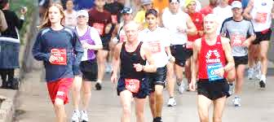

Learn 2 Run Week 1
Registration
Foot and Gait Analysis
Program Overview and Information Session
Warm Up / 2 min Walk / 2 min Slow Jog x 5 / Cool Down / Stretching

HOMEWORK: 2 – 3 days in addition to clinic night
5 – 10 min. warm-up (walk)
Runners: Alternate 2 min walking / 2 min. slow jogging x 5
Power Walkers: Alternate 2 min. regular pace / 2 min. accelerated pace
5 min cool down (walk)
Stretching
Weekly Tip
There are 2 important things to remember when you start running or power walking:
USE PROPER FORM
STRETCH AFTER EVERY RUN
Go to www.carp.ca/brockville for TIPS ON PROPER RUNNING FORM and a list of MUST DO STRETCHES for walkers and runners
FALL TRAIL RUN
EDGEWOOD FARMS, Addison ON
Saturday October 13th, 2012
1k starts at 9:00 am 5k starts at 9:15 am
www.brockvilleroadrunners.com

