RUN BROCKVILLE

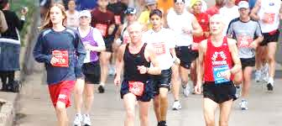

Learn 2 Run AND Power Walking Week 3

CLINIC NIGHT: Warm Up / 2 min Walk, 2 min Jog x 2 / 2 Walk, 6 min Jog x 3 / Cool Down

HOMEWORK: 2 – 3 days in addition to clinic night
Runners: 1. 5 – 10 min. warm-up (brisk walking)
2. 2 min walking / 3 min. slow jogging x 2
2 min walking / 5 min. slow jogging (once)
GOAL: 2 min walking / 8 min. slow jogging (once)
5 min. cool down with a brisk walk
Stretching – stretch gently and hold for 15 – 30 seconds
Power Walkers:
1. 5 – 10 min. warm-up (brisk walking)
2. 2 min walking / 3 min. accelerated pace x 2
2 min walking / 5 min. accelerated pace (once)
2 min walking / 8 min. accelerated pace (once)
When you reach the hill on the path coming back, repeat once with proper technique
3. 5 min. cool down with a brisk walk
Stretching – remember to stretch gently and hold for 15 – 30 seconds

Weekly Tip
If you’re new to jogging or power walking, you may find the first several weeks rather difficult. You are engaging muscles that have been hibernating and you are teaching your body something that it’s not used to doing. Remember that this is an exciting time for you! You are going farther, getting faster and stronger every week! Soon your body will love its new activity and your runs will be painless and effortless.

