RUN BROCKVILLE

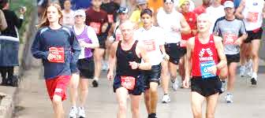

Learn 2 Run AND Power Walking Week 4

CLINIC NIGHT: Warm Up / 2 min Walk - 2 min Jog x 2 / 2 min. Walk - 5 min Jog x 2 / 2 min. walk – 10 min jog (once ) / 5 min. Cool Down

HOMEWORK: 2 – 3 days in addition to clinic night
Runners: 1. 5 – 10 min. warm-up (brisk walking)
2. 2 min walking / 3 min. slow jogging x 2
2 min walking / 5 min. slow jogging (once)
GOAL: 2 min walking / 12 min. slow jogging (once)
5 min. cool down with a brisk walk
Stretching – stretch gently and hold for 15 – 30 seconds
Power Walkers:
1. 5 – 10 min. warm-up (brisk walking)
2. 2 min walking / 3 min. accelerated pace x 2
2 min walking / 5 min. accelerated pace (once)
2 min walking / 12 min. accelerated pace (once)
When you reach the hill on the path coming back, repeat once with proper technique
3. 5 min. cool down with a brisk walk
Stretching – remember to stretch gently and hold for 15 – 30 seconds

Weekly Tip
You’re getting stronger and we are going farther each week! Remember to PACE SLOWLY. If you’re moving too quickly it will be much more difficult to complete the longer intervals.

