RUN BROCKVILLE

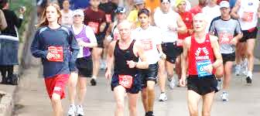

Learn 2 Run AND Power Walking Week 5

CLINIC NIGHT: Warm Up / 2 min Walk - 2 min Jog x 2 / 2 min. Walk - 5 min Jog x 2 / 2 min. walk – 15 min jog (once ) / 5 min. Cool Down

HOMEWORK: 2 – 3 days in addition to clinic night
Runners: 1. 5 – 10 min. warm-up (brisk walking)
2. 2 min walking / 3 min. slow jogging x 2
2 min walking / 5 min. slow jogging (once)
2 min walking / 15 min. slow jogging (once)
5 min. cool down with a brisk walk
GOAL: 1 x 18 Min Interval
Power Walkers: INTERVAL TRAINING: This training schedule will be used on clinic night and 2 additional homework days
1. 5 – 10 min. warm-up (brisk walking)
2. 2 min walking / 2 min. accelerated pace x 4
2 min walking / 5 min. accelerated pace (2)
3. Cool Down
2 DAYS:
1. 5 – 10 min. warm-up (brisk walking)
2. 2 min walking / 2 min. accelerated pace x 4
2 min walking / 15 min. accelerated pace
3. Cool Down

