RUN BROCKVILLE

YOU’RE ALMOST THERE!
GRADUATION NIGHT
Tuesday November 13, 2012
6:00 – 8:00pm

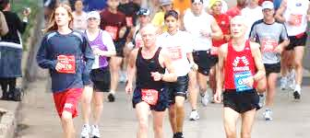

Learn 2 Run AND Power Walking Week 6

CLINIC NIGHT: Warm Up / 2 min Walk - 2 min Jog x 2 / 2 min. Walk - 5 min Jog x 2 / 2 min. walk – 22 min jog (once ) / 5 min. Cool Down

HOMEWORK: 2 – 3 days in addition to clinic night
Runners: 1. 5 – 10 min. warm-up (brisk walking)
2. 2 min walking / 3 min. slow jogging x 2
2 min walking / 5 min. slow jogging (once)
2 min walking / 22 min. slow jogging (once)
5 min. cool down with a brisk walk

Power Walkers: DISTANCE TRAINING:
CLINIC NIGHT: Warm Up. 2 min Walk - 2 min Jog x 3 / 2 min. Walk 20 accelerated pace

1. 5 – 10 min. warm-up (brisk walking)
2. 2 min walking / 2 min. accelerated pace x 3
2 min walking / 20 min. accelerated pace (ONCE)
3. Cool Down
STRETCH !

