CARP Community: Focus on Health

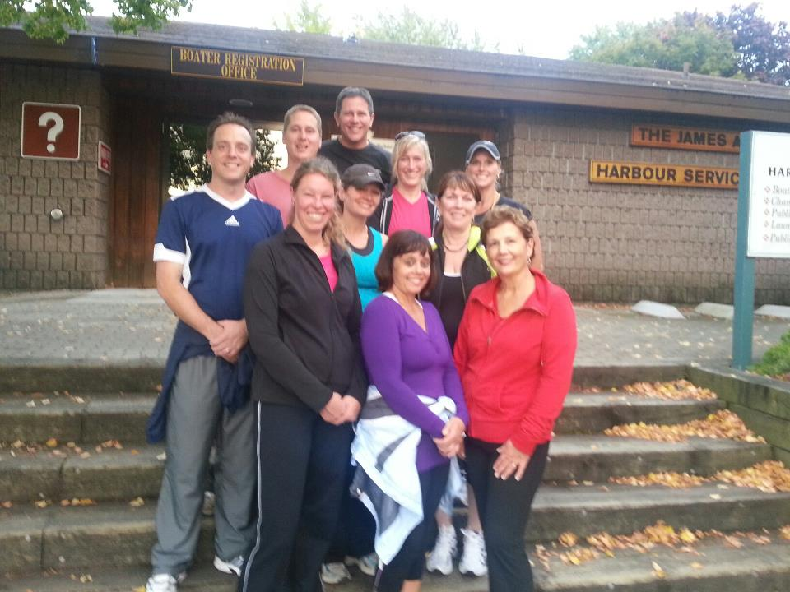

CARP Brockville, Power Walking, Learn to Run Group Fall 2012
• • •
“I felt the right time presented itself to bring back the Power Walking and Run Clinics this Fall after a two year hiatus. In the last year, I see more walkers, runners and cyclists over the age of 50 than any other age group. I am inspired by the Zoomers in our community every day! There’s John and Mary who are always training for that next half marathon, my spin group at the YMCA where 95% of the class is over 60 and spinning with the energy of a 20 year old, or Alan and the cycling group hanging out at Bobili Cafe after biking 90km or more!

I am proud to live in a community where health is trendy and valued. As we face a future of health care overload particularly with the baby boomer generation reaching 65, it’s comforting to know that our community is taking preventative measures and leading the way to a healthy community!

It doesn’t matter how old you are, what the scale says or if you have never exercised in your life. Designed for the beginner and intermediate in mind, our programs provide the opportunity for everyone to get active.”
Coach: Dawn Edgley
Take the first step towards a healthy and happy you! For everything you need to get started go to
: www.carp.ca/brockville

Brockville, Thousand Islands CARP Chapter #40

Fall 2012 NEWSLETTER

[Type the company name] | [Pick the date] | [Edition 1, Volume 1]

Exercise for the Aging Brain
Generally we start the aging process around the age of 30. By 40, if you’re not doing some type of exercise bones start to deteriorate, muscle tissue becomes weak and can easily get damaged. Overall, the body is not as healthy, strong and vibrant as it would be if a form of
exercise was included. The brain is our most vital organ and should be treated and exercised like the most important muscle in the body. “Exercise is the single most powerful tool you have to optimize your brain function,” says Harvard psychologist John Ratey, M.D., and author of the book Spark: The Revolutionary New Science of Exercise and the Brain.

Neuroscientists explain that exercise increases blood flow in the brain, encourages activity between the neurons, and even promotes new neurons to grow in the hippocampus, which plays a major role in memory and learning.

The endorphins are the
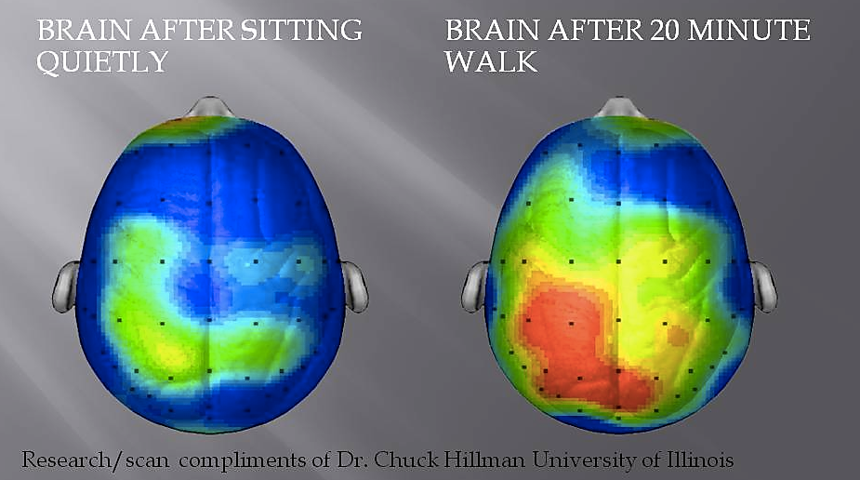
Endorphins are a chemical to fight stress and tend to minimize the discomfort of exercise, block the feeling of pain and are associated with a feeling of euphoria.

reasons exercise makes us feel so good. The somewhat scary part is that they have a very similar and addictive behavior like morphine, heroine or nicotine. The only difference? Well, it’s actually good for us!
CARP Brockville Chapter # 40: www.carp.ca/brockville (613) 802-0424 or e-mail: Board Chair: Dawn Edgley at edgley.carp@gmail.com

CARP is a proud affinity partner with CHARTWELL Senior Housing, locally known as The Rosedale. Thank you to Manager Todd Cook and Rosedale Representative Ryan Carroll for hosting a fabulous chicken BBQ for residents and community partners!
With a CARP Membership, you or your loved ones are eligible for one month free rent with your new residency at Rosedale Retirement Home. CLICK HERE to find out more.
STAY CONNECTED WITH YOUR LOCAL CHAPTER! JOIN THE CONVERSTATION AND STAY CONNECTED. Join us on the CARP BROCKVLLE Facebook Page or send us an ‘add’ on LinkedIn! Chapter updates are also posted regularly on our website at: www.carp.ca/brockville
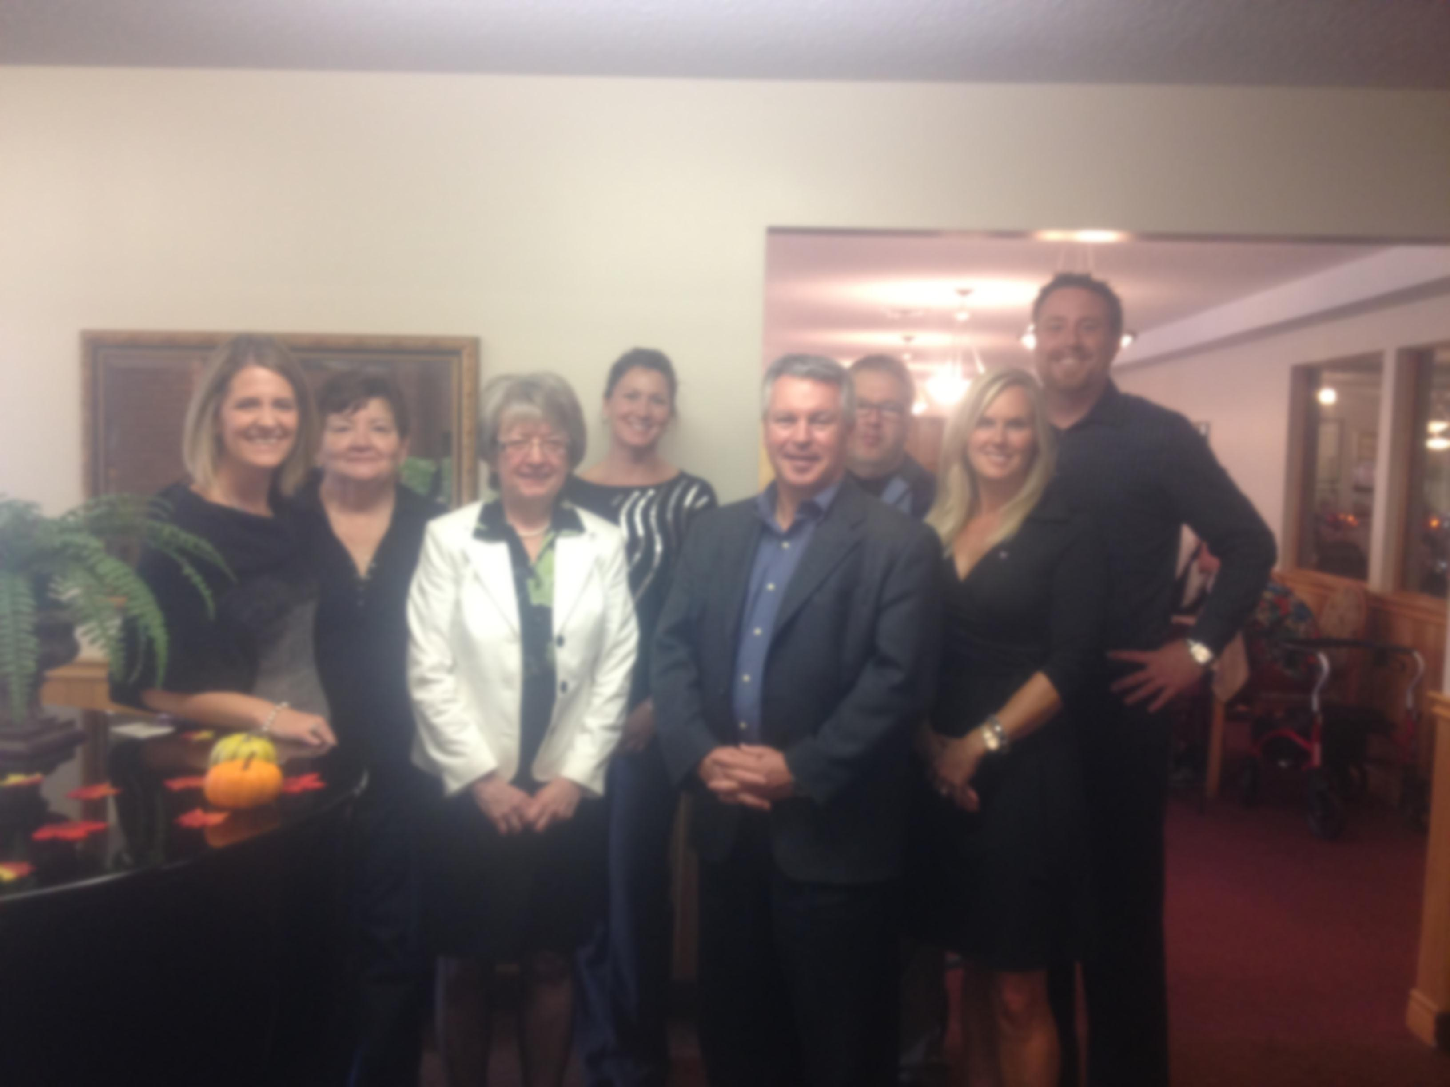
Health and Lifestyle Expo ZOOMER STYLE! Recap:
It was an action packed day enjoyed by everyone! The ‘lifestyle’ event was held at the Brockville Country Club with over 45 interactive vendors, a full day of musical entertainment, food, mini ‘try-it’ fitness clinics and more! The show will become an annual event with a variety that will appeal to everyone. We are preparing to host the show in early spring, 2013. If you are interested in becoming a vendor or join our planning committee for 2013 please contact board chair: Dawn Edgley: edgley.carp@gmail.com
Brockville Chapter: Lecture Series
Stay tuned for our upcoming series of lectures starting Wednesday December 5^{th.} The purpose of this lecture series is to bring CARP members and future members together monthly to socialize with like-minded people and hear experts talk about the issues that matter to you. People surveyed locally say they want issues such as: Adjusting to Retirement Lifestyle, How NOT to Outlive Your Money, Aging at Home – Start Planning Now!, Social Media and Technology ‘101’, Dealing with Elder Abuse, Healthy Brains and Bodies after 50, and more. Please go to our website to register your name and receive a personal invitation.
Age Friendly Communities
We continue to explore the WHO Age Friendly Communities initiative which will compliment Brockville’s SAFE COMMUNITY INITIATIVE and YOUTH FRIENDLY INITIATIVE. The designation is of tremendous value for city residents of every age! The project requires the support of dedicated volunteers who are able to contribute (a lot or a little) to the success of this designation. Please contact: Dawn Edgley at (613) 802-0424 to get involved.

CARP IS GROWING IN EASTERN ONTARIO!
Congratulations to the new Lanark County CARP Chapter!
There’s an enthusiastic and dedicated team leading the way towards an Age Friendly Lanark! Visit their website to meet the board of directors and find out about upcoming events:
October 19th, 2012 INSIGHTS ON DEMENTIA
November 5th, 2012 ASSISTIVE TECHNOLOGY FOR SENIORS WORKSHOP
www.carp.ca/almonte

