Exercise for the Aging Brain

Think you’re too young for this article? Think again. Generally we start the aging process around the age of 30. By 40, if you’re not doing some type of exercise bones start to deteriorate, muscle tissue becomes weak and can easily get damaged. Overall, the body is not as healthy, strong and vibrant as it would be if a form of exercise was included.
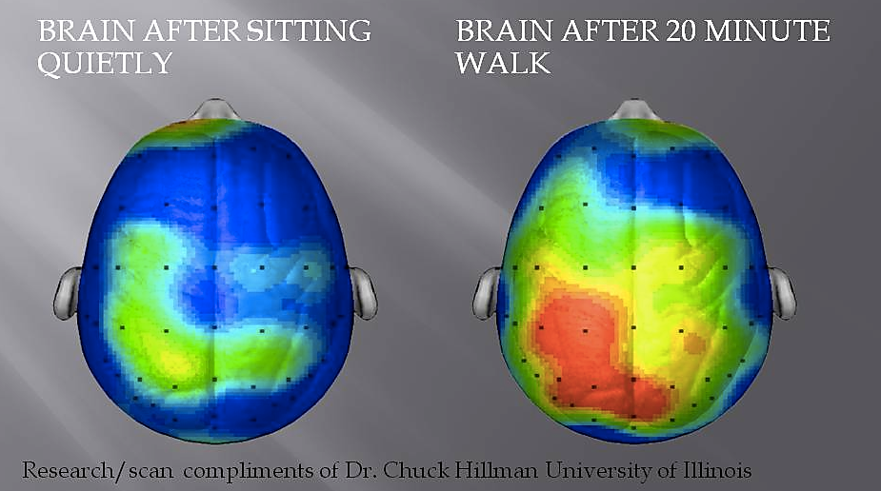
Endorphins are a chemical to fight stress and tend to minimize the discomfort of exercise, block the feeling of pain and are associated with a feeling of euphoria.

The brain is our most vital organ and should be treated and exercised like the most important muscle in the body.
“Exercise is the single most powerful tool you have to optimize your brain function,”
Harvard psychologist John Ratey, M.D., and author of the book Spark: The Revolutionary New Science of Exercise and the Brain.
Neuroscientists explain that exercise increases blood flow in the brain, encourages activity between the neurons, and even promotes new neurons to grow in the hippocampus, which plays a major role in memory and learning.

The endorphins are the reasons exercise makes us feel so good. The somewhat scary part is that they have a very similar and addictive behavior like morphine, heroine or nicotine. The only difference? Well, it’s actually good for us!

