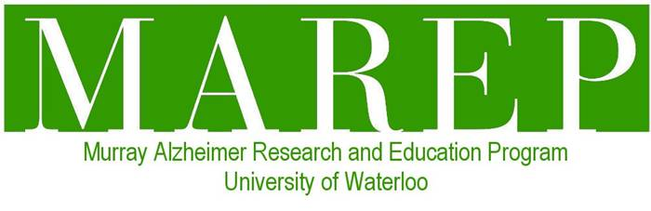
Enhancing Relationship-Centred Care through Research-Based Drama

Summary Sheet for Dementia Champions

My name is Sherry Dupuis and I am the director of the Murray Alzheimer Research and Education Program (MAREP) at the University of Waterloo. I would like to invite you to participate in a new project, “Enhancing Relationship-Centred Care through Research-Based Drama”.

Why is this project being conducted?
- Recent research demonstrates that the arts are an important and effective way of changing images and understandings of dementia and the way that care is provided, enhancing the quality of life of persons with dementia and their family members.
- Research also demonstrates the profound impact the current dominant and negative way dementia is viewed – the tragedy discourse – has on relationships for both persons with dementia and their family members.
- Information gathered through this project will be used in the development of a new research-based drama focused on relationships in dementia that will be used to educate persons with dementia, family members and staff about the importance of relationships and how to enhance relationships for all those experiencing dementia. It will also be used to challenge the dominant view of dementia and begin to develop an alternative perspective, one based on the experiences of persons living with dementia.

Who can participate in this study?
- I am looking for persons living with memory loss who are willing to assist me in constructing an alternative way of viewing dementia.
- Participants should be willing and able to sign an informed consent form to participate in this project.

What will be asked of participants in the project?
- You will be asked to participate in a one day workshop from 10 -3 in Toronto, Ontario.
- In the morning, you will be asked to participate in group discussion with me and other persons with memory loss that should last approximately 1.5 hours in length.
- I would like to audio record the group discussion so I make sure I adequately capture your information. Quotes from the discussion may be used in the development of the play script but only if you provide consent to use your quotes.
- In the afternoon, you will be paired with an artist from the community and one of the actors in the play and work with them to create a placard that reflects what you want people to know about you and the experience of memory loss.
- This is a unique workshop and so in order to capture the process, I will also be video-recording the workshop. Images from the video-taped segments may be used for educational purposes but only images of those individuals who provide consent will be used for these purpose.
- The group discussion is scheduled for November 29 from 10 a.m. to 3 p.m. at the Toronto Rehabilitation Institute at 550 University Avenue in Toronto. All of your travel expenses will be covered by the project

What should you know about your participation in this study?
- Your participation is completely voluntary.
- You can refuse to answer any questions you want.
- You will simply be asked to share how you want the world to view persons living with dementia. You can share as much or as little information as you feel comfortable.
- Few, if any, risks, of participating in this project are anticipated.
- You will be asked to consider whether or not you want your name associated with the project and with the placard you create. Only the names of those who provide written consent will be shared.
- Participation in group discussions means that you will see and be seen by persons in your group and by researchers. Before the group session begins, all participants will be asked to keep what is heard in the discussion session confidential by not sharing what is discussed during the session with others outside of the group.
- The meeting will be audio recorded and video-recorded.
- With your permission, anonymous quotations from the morning discussion may be used in the development of the script for the play or in other presentations or education sessions conducted by MAREP staff.
- Images from the video-recording may be used for educational purposes but only images of those who provide consent will be used for these purposes.
- You may withdraw from participating at any time by advising me. Should you decide during the session or at a later date that you would prefer that the information you shared with us during the workshop not be included in the development of the script for the play or in other presentations or education sessions, you can contact me and your information/stories shared will be removed.
- Final placards created for the project will be owned by MAREP. If agreed by all parties who create the placard, the names of the creators will appear on the individual placards.
- Data will be retained indefinitely in a secure location, with the exception of paper records, which will be destroyed 2 years after the completion of the study, and audio and video recordings will be kept indefinitely. Any personally identifying information will be removed from the stored data.
- Once the play is completed you will be invited to a performance of the play.

Who to contact should you have any questions about the study?
- Please contact me, Sherry Dupuis if you have any questions or concerns about this project. I can be contacted at (519) 888-4567, Ext. 36188, or by email at sldupuis@uwaterloo.ca.
- This project has been reviewed by, and received ethics clearance through the Office of Research Ethics at the University of Waterloo. Any comments or concerns can be addressed to the Director, Maureen Nummelin, at 519-888-4567, Ext. 36005 or by e-mail at maureen.nummelin@uwaterloo.ca.

Thank you in advance for your interest in this project!

